Stromness Surgery

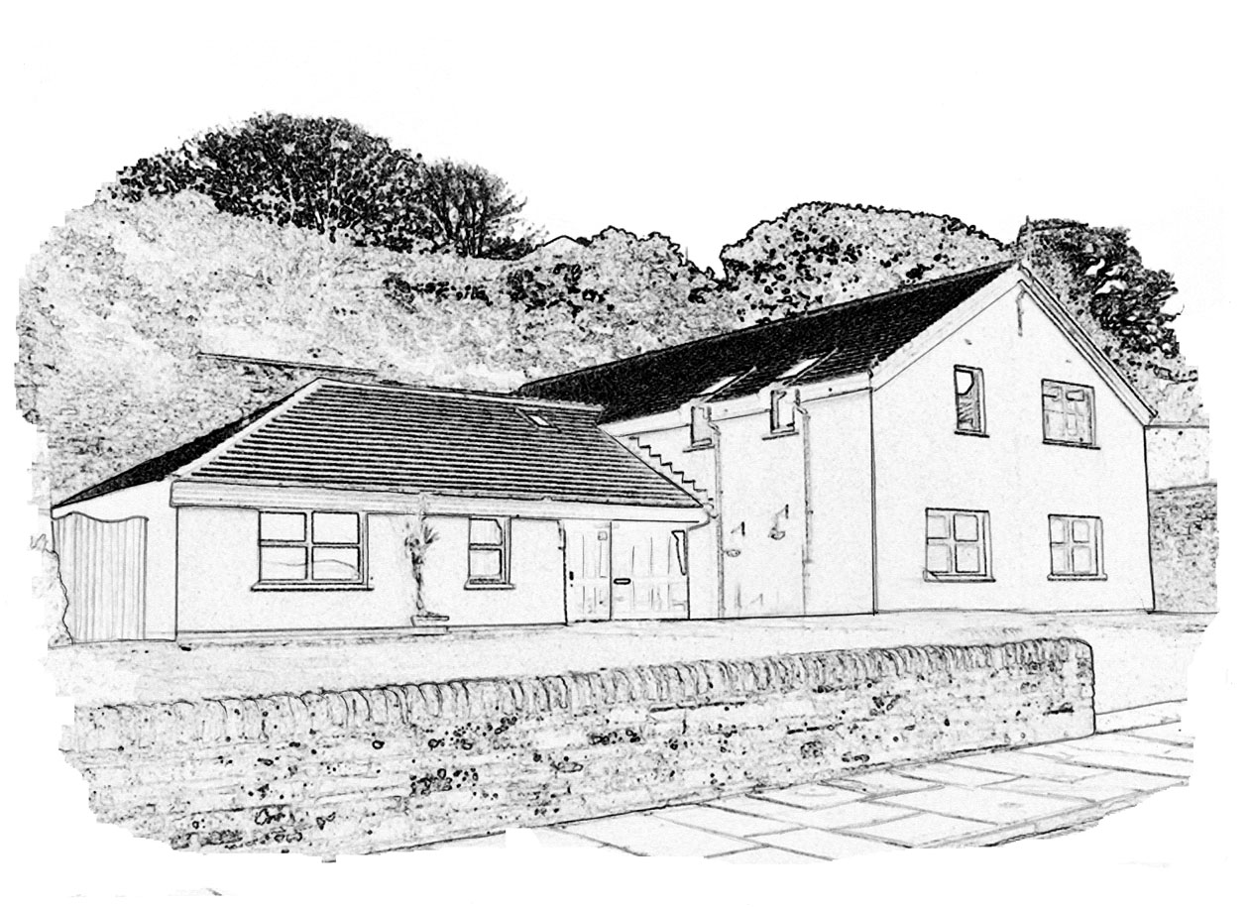

Complaints Handling Procedure

Quick guide to the NHS complaints procedure

Complaints procedure
You can make your complaint in person, by phone, by e-mail or in writing.

We have a two-stage complaints procedure. We will always try to deal with your complaint quickly. But if it is clear that the matter will need a detailed investigation, we will tell you and keep you updated on our progress.
Stage one: early, local resolution

We will always try to resolve your complaint quickly, within five working days if we can.

If you are dissatisfied with our response, you can ask us to consider your complaint at Stage two.
Stage two: investigation

We will look at your complaint at this stage if you are dissatisfied with our response at Stage one. We also look at some complaints immediately at this stage, if it is clear that they are complex or need detailed investigation.

We will acknowledge your complaint within three working days. We will give you our decision as soon as possible. This will be after no more than 20 working days unless there is clearly a good reason for needing more time.
The Scottish Public Services Ombudsman

If, after receiving our final decision on your complaint, you remain dissatisfied with our decision or the way we have handled your complaint, you can ask the SPSO to consider it.
We will tell you how to do this when we send you our final decision.

We will tell you how to do this when we send you our final decision.

Stromness Surgery complaints procedure

Stromness Surgery is committed to providing high quality care and treatment to people in our communities through the delivery of safe, effective and person-centred care. We understand, however, that sometimes things go wrong. If you are dissatisfied with something we have done, or have not done, please tell us and we will do our best to put things right. If we cannot resolve matters in the way you want, we will explain why it’s not possible to do as you suggest.

This leaflet tells you about our complaints procedure and how to make a complaint. It includes information about what you can expect from us when we are dealing with your complaint.

What is a complaint?
We regard a complaint as:

Any expression of dissatisfaction about our action or lack of action, or about the standard of service provided by us or on our behalf.

If you need to complain about something, we encourage you to do so. We also understand that your complaint may involve more than one NHS body or service, or relate to both health and social care services, or it may be about someone working on our behalf. Our complaints procedure covers all of these possibilities.

Who can complain?
Anyone can make a complaint to us. You can complain directly to us, or if you would rather have someone make the complaint on your behalf, we can deal with your representative. This could be a relative, a carer, a friend or any other person that you choose. We can also give you information about advocacy services, and about the Patient Advice and Support Service, which can help you to make your complaint. If you agree to someone making the complaint on your behalf, it is important for you to know that we will need to ask for your permission for us to deal with that person.

What can I complain about?
You can complain about things like:

- Your care and/or treatment;
- delays;
- a failure to provide a service;
- an inadequate standard of service;
- a lack of information and clarity about appointments;
- difficulty in making contact with us for appointments or queries;
- treatment by or attitude of a member of our staff;
- scheduled or unscheduled ambulance care;
- transport concerns, either to, from or within the healthcare environment;
- environmental or domestic issues;
- operational and procedural issues;
- our failure to follow the appropriate process; and
- your dissatisfaction with our policy.

We realise that it is not possible to list everything that you can complain about. If you want to complain about something that we have not listed above, we encourage you to do so.

What can’t I complain about?
There are some things we cannot deal with through our complaints handling procedure. These include:

- a routine first-time request for a service, for example a request for an appointment or a request for a specific course of treatment;
- a request for a second opinion in respect of care or treatment;
- matters relating to private healthcare or treatment;
- matters relating to services not provided by or funded by the NHS;
- a previously concluded complaint or a request to have a complaint reconsidered where we have already given our final decision;
- a complaint made by an employee of the NHS Board or health service provider or other person in relation to their employment contract;
- a complaint that is being or has been investigated by the Scottish Public Services Ombudsman (SPSO);
- a complaint arising from a suggested failure to comply with a request for information under the Freedom of Information Act; and
- a complaint about which you have commenced legal proceedings, or have clearly stated that you intend to do so, rather than pursue the matter using the NHS complaints procedure.

We also realise that it is not possible to list everything that you cannot complain about. If other procedures can help you resolve your concerns, we will give information and advice to help you.

How do I complain?
You can complain in person at the place where you have received care, treatment or advice, or where the incident that you want to complain about happened. You can also complain by phone, in writing, by email or in person.

Wherever possible we encourage you to speak with a member of staff. It’s easier for us to resolve complaints if you make them quickly and directly to the service concerned. So please talk to a member of our staff at the service you are complaining about. They will always try to resolve any problems on the spot if it is possible to do so.

When complaining, please tell us:

- your full name and address, and your email address if this is your preferred method of contact;
- the full name, address and date of birth of the person affected if you are complaining on behalf of somebody else;
- as much as you can about the complaint;
- what has gone wrong;

- when did this happen;
- where did this happen; and
- how you want us to resolve the matter.

Giving us this information will help us to clearly identify the problem and what we need to do to resolve matters.

How long do I have to make a complaint?
Normally, you must make your complaint within six months of:
- the event you want to complain about; or
- finding out that you have a reason to complain, but no longer than 12 months after the event itself.

In exceptional circumstances, we may be able to accept a complaint after the time limit. If you feel that the time limit should not apply to your complaint, please tell us why. If we decide that, because of the time that has passed since the incident occurred, we cannot consider your complaint, you can ask the Scottish Public Services Ombudsman (SPSO) to review our decision.

What happens when I have complained?
We will always tell you who is dealing with your complaint. Our complaints procedure has two stages:

Stage one – early, local resolution
We aim to resolve complaints quickly and close to where we provided the service. Where appropriate, this could mean an on-the-spot apology and explanation if something has clearly gone wrong, and immediate action to resolve the problem.

Sometimes we will have to make some enquiries before we can respond to your complaint. We will give you our decision at Stage one in five working days or less, unless there are exceptional circumstances.

If we cannot resolve your complaint at this stage, we will explain why and tell you what you can do next. We might suggest that you take your complaint to Stage two. You may choose to do this immediately or sometime after you get our initial decision.

Stage two – investigation

Stage two deals with two types of complaint: those that have not been resolved at Stage one and those that are complex and require detailed investigation.

When using Stage two we will:
- acknowledge receipt of your complaint within three working days;
- where appropriate, discuss your complaint with you to understand why you remain dissatisfied and what outcome you are looking for; and
- give you a full response to the complaint as soon as possible and within 20 working days.

If our investigation will take longer than 20 working days, we will tell you. We will agree revised time limits with you and keep you updated on progress.

What if I’m still dissatisfied?
If you are still dissatisfied with our decision or the way in which we have dealt with your complaint when we have sent you our full response, you can ask the SPSO to look at it.

The SPSO cannot normally look at:
- a complaint that has not completed our complaints procedure, so please make sure it has done so before contacting the SPSO;
- events that happened, or that you became aware of, more than a year ago; or
- a matter that has been or is being considered in court.

You can contact the SPSO:

In Person: By Post
SPSO SPSO
Bridgeside House FREEPOST SPSO
99 McDonald Road
Edinburgh
EH7 4NS

Freephone: 0800 377 7330
Online contact www.spso.org.uk/contact-us
Website: www.spso.org.uk
Mobile site: http://m.spso.org.uk

Getting help to make your complaint

We understand that you may be unable, or reluctant, to make a complaint yourself. We accept complaints from the representative of a person who is dissatisfied with our service as long as the person has given their permission for us to deal with that person. We can take complaints from a friend, relative, or an advocate, if you have given them your consent to complain for you.

The Patient Advice and Support Service (PASS) is an organisation that provides free and confidential advice and support to patients and other members of the public in relation to NHS Scotland. The service promotes an awareness and understanding of the rights and responsibilities of patients and can advise and support people who wish to make a complaint to the NHS. Further information and contact details can be found on the PASS web site:

www.patientadvicescotland.org.uk or Telephone 0800 9172127

We are committed to making NHS services easy to use for all members of the community. In line with our statutory equalities duties, we will always ensure that reasonable adjustments are made to help you to access and use our services. If you have trouble putting your complaint in writing, or want this information in another language or format, tell us in person.

Our contact details are:

Mrs Paula Craigie
Practice Manager
Stromness Surgery
John Street
Stromness
Orkney
KW13 AD

Telephone 01856 850205
Email – paula.craigie@nhs.scot

Paula Craigie
June 2025

